***ANUDIP FOUNDATION***

A Project Report on

**AI Based Interview Simulator**

By

Batch: ANP-D0453

Student ID: AF0477046

Name : Sakshi Nalwar

**Under the Guidance of**

Mrs. Rajshri Chandrabhan Thete

The AI-Based Interview Simulator is a web-based application designed to help job seekers prepare for technical and HR interviews through an AI-powered interactive platform. It generates realistic interview questions, evaluates user responses, and provides feedback based on AI-driven analysis. The system mimics real-world interview scenarios to enhance candidates' confidence, communication skills, and subject knowledge.

**Entities:**

**❖ User**

**❖ Interview Session**

**❖ Question**

**❖ Answer**

**❖ Response**

**❖ Report**

**ATTRIBUTES OF ENTITIES:**

**1. UserAttributes:**

**●** User_id (primary key)

● Name

● Mobile_No (Unique)

● Email (Unique)

● Password

● Experience_level

**2. Interview_SessionAttributes:**

**●** Session_Id (primary key)

● User_Id (foreign key)

● Schedule_Date

● Start_Time

● End_Time

**3. QuestionAttributes:**

**●** Q_id (primary key)

● Question_Text

● Difficulty_level

● Session_Id (foreign key)

**4. AnswerAttributes:**

**●** Answer_Id (primary key)

● Q_ID (foreign key)

● Answer_Text

● Question_Text

**5. ResponseAttributes:**

**●** Response_Id (primary key)

● User_Id (foreign key)

● Q_Id (foreign key)

● Response_Text

● Correct_Answer

● AI_Score

● AI_Feedback

**6. ReportAttributes:**

**●** Report_Id (primary key)

● Session_Id (foreign key)

● Response_Id (foreign key)

● Q_ID (foreign key)

● User_Id (foreign key)

● Improvement_Suggestions

**ENTITY RELATIONSHIP DIAGRAM – AI Based Interview Simulator**

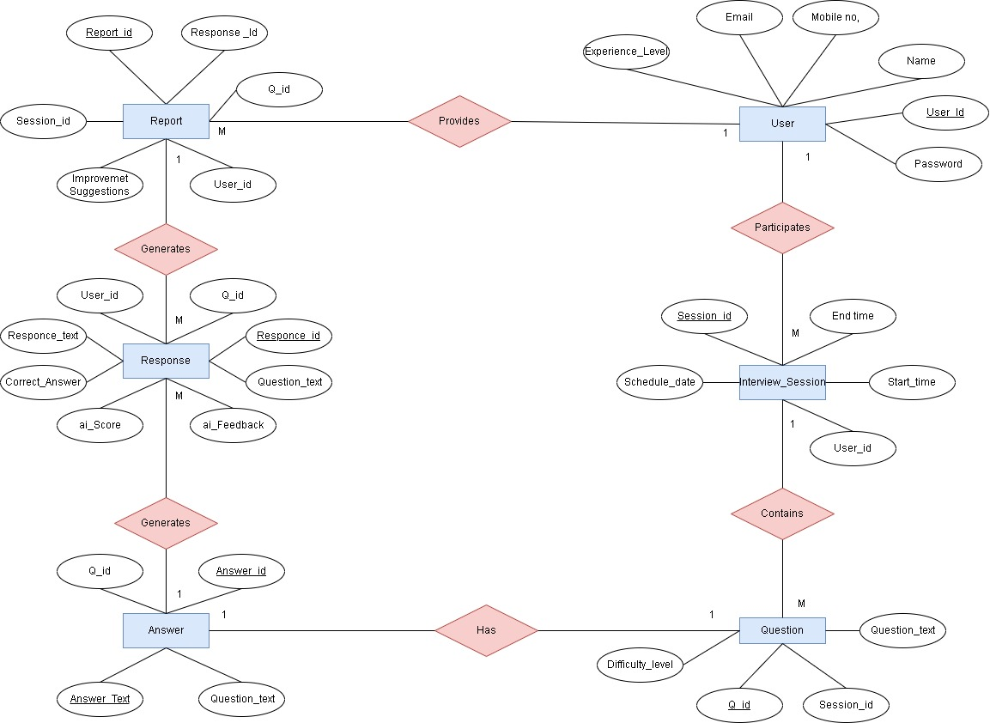

**Database Creation :**

CREATE DATABASE InterviewSimulator;

USE InterviewSimulator;

**-- User Table**

CREATE TABLE User (

User_Id INT NOT NULL AUTO_INCREMENT,

Name VARCHAR(100) NOT NULL,

Email VARCHAR(100) NOT NULL UNIQUE,

Mobile_NoVARCHAR(15) NOT NULL UNIQUE,

Password VARCHAR(255) NOT NULL,

Experience_LevelVARCHAR(50),

PRIMARY KEY (User_Id)

);

-- **Interview Session Table**

CREATE TABLE Interview_Session (

Session_Id INT NOT NULL AUTO_INCREMENT,

User_Id INT,

Schedule_Date DATE NOT NULL,

Start_Time TIME NOT NULL,

End_Time TIME NOT NULL,

PRIMARY KEY (Session_Id),

FOREIGN KEY (User_Id) REFERENCES User(User_Id) ON DELETE SET NULL

);

-- **Question Table**

CREATE TABLE Question (

Q_Id INT NOT NULL AUTO_INCREMENT,

Question_Text TEXT NOT NULL,

Difficulty_LevelVARCHAR(50),

Session_Id INT,

PRIMARY KEY (Q_Id),

FOREIGN KEY (Session_Id) REFERENCES Interview_Session(Session_Id) ON DELETE SET NULL

);

-- **Answer Table**

CREATE TABLE Answer (

Answer_Id INT NOT NULL AUTO_INCREMENT,

Q_Id INT UNIQUE,

Answer_Text TEXT NOT NULL,

Question_Text TEXT NOT NULL,

PRIMARY KEY (Answer_Id),

FOREIGN KEY (Q_Id) REFERENCES Question(Q_Id) ON DELETE CASCADE

);

-- **Response Table**

CREATE TABLE Response (

Response_Id INT NOT NULL AUTO_INCREMENT,

User_Id INT,

Q_Id INT,

Response_Text TEXT NOT NULL,

Correct_Answer TEXT NOT NULL,

AI_ScoreDECIMAL(5,2),

AI_Feedback TEXT,

PRIMARY KEY (Response_Id),

FOREIGN KEY (User_Id) REFERENCES User(User_Id) ON DELETE SET NULL,

FOREIGN KEY (Q_Id) REFERENCES Question(Q_Id) ON DELETE CASCADE

);

**-- Report Table**

CREATE TABLE Report (

Report_Id INT NOT NULL AUTO_INCREMENT,

Session_Id INT,

Response_Id INT,

Q_Id INT,

User_Id INT,

Improvement_Suggestions TEXT,

PRIMARY KEY (Report_Id),

FOREIGN KEY (Session_Id) REFERENCES Interview_Session(Session_Id) ON DELETE SET NULL,

FOREIGN KEY (Response_Id) REFERENCES Response(Response_Id) ON DELETE CASCADE,

FOREIGN KEY (Q_Id) REFERENCES Question(Q_Id) ON DELETE CASCADE,

FOREIGN KEY (User_Id) REFERENCES User(User_Id) ON DELETE SET NULL

);

**Output :**

mysql> use interviewSimulator;

Database changed

mysql> show tables;

+------------------------------+

| Tables_in_interviewsimulator |

+------------------------------+

| answer |

| interview_session |

| question |

| report |

| response |

| user |

+------------------------------+

6 rows in set (0.17 sec)

mysql>desc answer;

+---------------+------+------+-----+---------+----------------+

| Field | Type | Null | Key | Default | Extra |

+---------------+------+------+-----+---------+----------------+

| Answer_Id | int | NO | PRI | NULL | auto_increment |

| Q_Id | int | YES | UNI | NULL | |

| Answer_Text | text | NO | | NULL | |

| Question_Text | text | NO | | NULL | |

+---------------+------+------+-----+---------+----------------+

4 rows in set (0.07 sec)

mysql>descinterview_session;

+---------------+------+------+-----+---------+----------------+

| Field | Type | Null | Key | Default | Extra |

+---------------+------+------+-----+---------+----------------+

| Session_Id | int | NO | PRI | NULL | auto_increment |

| User_Id | int | YES | MUL | NULL | |

| Schedule_Date | date | NO | | NULL | |

| Start_Time | time | NO | | NULL | |

| End_Time | time | NO | | NULL | |

+---------------+------+------+-----+---------+----------------+

5 rows in set (0.00 sec)

mysql>desc question;

+------------------+-------------+------+-----+---------+----------------+

| Field | Type | Null | Key | Default | Extra |

+------------------+-------------+------+-----+---------+----------------+

| Q_Id | int | NO | PRI | NULL | auto_increment |

| Question_Text | text | NO | | NULL | |

| Difficulty_Level | varchar(50) | YES | | NULL | |

| Session_Id | int | YES | MUL | NULL | |

+------------------+-------------+------+-----+---------+----------------+

4 rows in set (0.00 sec)

mysql>desc report;

+-------------------------+------+------+-----+---------+----------------+

| Field | Type | Null | Key | Default | Extra |

+-------------------------+------+------+-----+---------+----------------+

| Report_Id | int | NO | PRI | NULL | auto_increment |

| Session_Id | int | YES | MUL | NULL | |

| Response_Id | int | YES | MUL | NULL | |

| Q_Id | int | YES | MUL | NULL | |

| User_Id | int | YES | MUL | NULL | |

| Improvement_Suggestions | text | YES | | NULL | |

+-------------------------+------+------+-----+---------+----------------+

6 rows in set (0.00 sec)

mysql>desc response;

+----------------+--------------+------+-----+---------+----------------+

| Field | Type | Null | Key | Default | Extra |

+----------------+--------------+------+-----+---------+----------------+

| Response_Id | int | NO | PRI | NULL | auto_increment |

| User_Id | int | YES | MUL | NULL | |

| Q_Id | int | YES | MUL | NULL | |

| Response_Text | text | NO | | NULL | |

| Correct_Answer | text | NO | | NULL | |

| AI_Score | decimal(5,2) | YES | | NULL | |

| AI_Feedback | text | YES | | NULL | |

+----------------+--------------+------+-----+---------+----------------+

7 rows in set (0.00 sec)

mysql>desc User;

+------------------+--------------+------+-----+---------+----------------+

| Field | Type | Null | Key | Default | Extra |

+------------------+--------------+------+-----+---------+----------------+

| User_Id | int | NO | PRI | NULL | auto_increment |

| Name | varchar(100) | NO | | NULL | |

| Email | varchar(100) | NO | UNI | NULL | |

| Mobile_No | varchar(15) | NO | UNI | NULL | |

| Password | varchar(255) | NO | | NULL | |

| Experience_Level | varchar(50) | YES | | NULL | |

+------------------+--------------+------+-----+---------+----------------+

6 rows in set (0.00 sec)

**CONCLUSION:**

The AI-Based Interview Simulator is a comprehensive platform designed to enhance the interview preparation experience by integrating artificial intelligence with an interactive question-and-answer system. Built using Java, Spring Boot, Hibernate, MySQL, HTML, and CSS, this project streamlines the interview process by allowing users to participate in mock interview sessions, submit responses, and receive automated feedback based on AI-driven evaluation.

One of the key strengths of this system is its ability to provide real-time assessments, allowing users to understand their strengths and weaknesses. By analyzing responses and generating feedback, the system helps candidates refine their answers, improve their problem-solving skills, and gain confidence before facing real interviews. The inclusion of a difficulty-based question bank ensures that users are challenged appropriately based on their experience level, making the preparation process more effective.